**How to Change and Reset Forgotten Root Password in RHEL 9**

While [installation of RHEL 9](https://www.tecmint.com/download-install-rhel-9-free/), the installer recommends we choose a complex password and while making the password complex enough, the chances of forgetting our password are quite high. And things get even more complex when your user is not even added to the **wheel** group (which allows a normal user to [elevate root privileges](https://www.tecmint.com/create-sudo-user-on-centos/) for a small amount of time).

This tutorial will guide you on how you can change your forgotten root password in 3 scenarios and we are quite sure that you’ll be able to recover your forgotten password at the end of this guide.

**Method 1: Changing Root Password in RHEL 9**

So if you are a root user and want to change your existing root password, you can accomplish this task with a single command.

# passwd

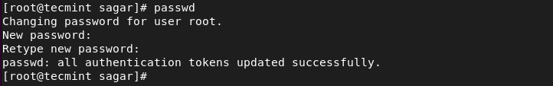Change Root Password in RHEL 9

And it will ask you to enter your new root password. For confirmation, it will ask you again for entering the new password and it will throw a message saying “**all authentication tokens updated successfully**”.

**Method 2: Changing Root Password as Sudo User**

For the majority, this will be the case where the user is added to the **wheel** group and want to change the root password. Thankfully, you can change your root password even if you don’t know the current one.

To change your root password as a **wheel** group user, utilize the given command:

$ sudo passwd root

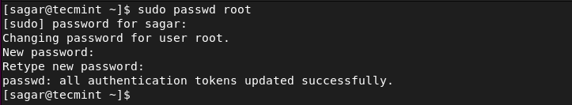Sudo User Change Root Password

First, you’ll be asked to enter your user password and after that, you’ll be allowed to change your root password by entering it twice and for confirmation.

**Method 3: Changing Forgotten Root Password in RHEL 9**

This method is for those who are not root users or their local user is not added to the **Wheel** group and still wants to change or reset their forgotten root password.

This is the most complex method and while using this method, make sure you read commands twice before applying them as we will be dealing with **GRUB**.

**Step 1: Enter GRUB Edit Mode**

To enter **GRUB** edit mode, first, we have to reboot our system. When you see **GRUB 2** screen, press the 'e' key to interrupt the boot process.

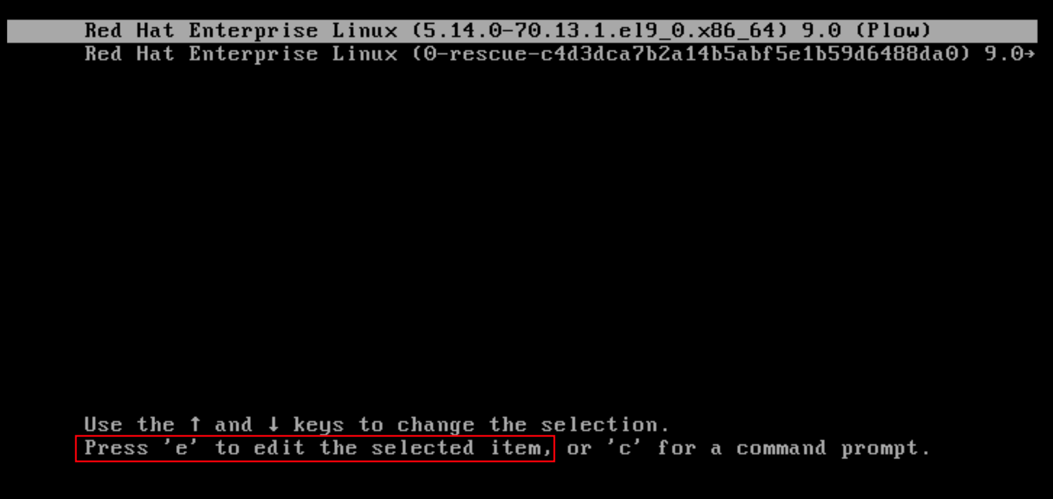RHEL Grub Boot Menu

Once you press 'e', it will show us kernel boot parameters.

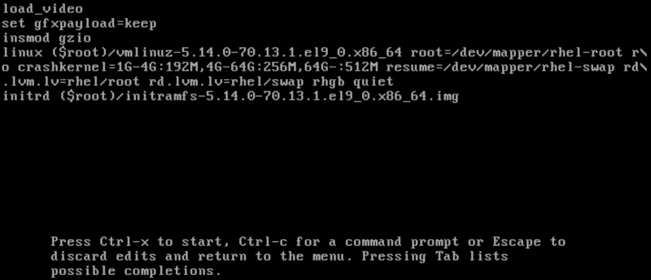Kernel Boot Parameters

**Step 2: Edit Kernel Boot Parameters**

Once you enter **Kernel** boot parameters, go to the end of the line which starts with linux. The easiest way to do that is first to go to the line that starts with linux and press CTRL + e to jump to the end of the line.

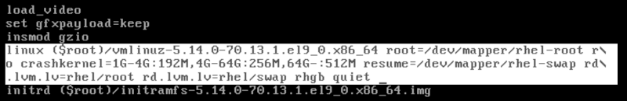View Kernel Boot Parameters

Once you are at the end of the line, add rd.break and press CTRL + x to start the system with changed parameters.

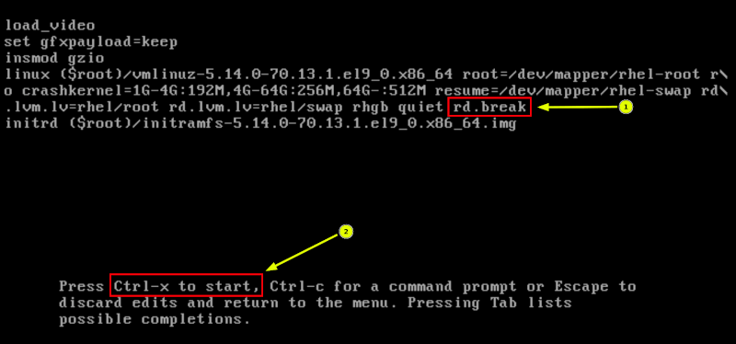Edit Kernel Boot Parameters

**Step 3: Reset Forgotten Root Password**

You will be given an emergency mode prompt. From here, we will be mounting our drives, entering into chroot environment, and changing our root password. Press **Enter** and the **sh-5.1** prompt will appear for further process.

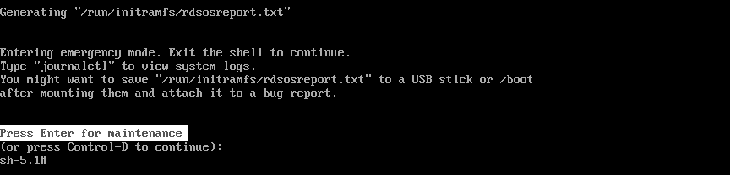RHEL Emergency Mode Prompt

By default, the file system is mounted as read-only under /sysroot directory. By using the given commands, we will be remounting them to make them writable and change our password.

# mount -o remount,rw /sysroot

After mounting drives, let’s enter into **chroot** environment which will allow us to make changes directly to system files.

# chroot /sysroot

Finally, we can change our root password by utilizing the given command:

# passwd

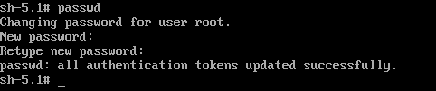Change Forgotten Root Password in RHEL 9

After changing the password, let’s enable **SELinux** relabeling process on the next system boot.

# touch /.autorelabel

After changing the password, let’s enable **SELinux** relabeling process on the next system boot.

# touch /.autorelabel

**Important**: We are not running any scripts here, so make sure you use /.autorelabel correctly.

After changing the password and relabeling, let’s exit chroot environment by the given command:

# exit

Similarly, to exit from the sh-5.1 prompt, we will be using the given command:

# exit

**Step 4: Verify Root Password**

To verify whether we have successfully changed our root password or not, log in as a normal user and open the terminal emulator and run an interactive shell as **root**, utilize the given command:  
$ su

Enter the newly configured root password. To print the username associated with a current user ID, we will be using the given command:

# whoami

Check Root User Login

And it will return as “**root**”.